A

PROJECT REPORT

ON

***“Caterers Website”***

By

*Mr. Mayur Sagane (192048)*

*Mr. Omkar Khamgaonkar (192025)*

**

**SAVITRIBAI PHULE PUNE UNIVERSITY, PUNE**

**MASTER IN COMPUTER APPLICATIONS**

**RAJARSHI SHAHU COLLEGE OF ENGINEERING PUNE-411003**

**2019-20**

**Jayawant Shikshan Prasarak Mandal’s**

**Rajarshi Shahu College of Engineering,**

**Department of MCA**

**Tathawade, Pune.**

Certificate

This is to certify that **Mrs. / Mr. Mayur Sagane**, **Omkar Khamgaonkar** is a bonafide student of **JSPM’s Rajarshi Shahu College of Engineering, Tathawade, Pune,** has successfully completed the project work as prescribed by the Savitribai Phule Pune University, in the partial fulfillment of the **Master of Computer Applications (MCA)** Programmer 2019-20.

**Roll No.: 192048**

**Roll No.: 192025**

**Date:**

**Place: Pune**

**Project Guide Head of Department**

**(Mr. Dipak B. Kadve) (Prof. Rinku A. Dullo)**

**Declaration**

To

The Principal,

Rajarshi Shahu College of Engineering,

Tathawade,

Pune-33.

Respected Sir,

I, **Mr. Mayur Sagane, Omkar Khamgaonkar** hereby declare that the project entitled

“ **Caterers Website**” developed and submitted under the guidance of **Prof. Dipak Kadve**, is my original work.

The system presented here is my own work and has not been duplicated from any other sources.

Thank You,

Yours Sincerely,

Mayur Sagane

Omkar Khamgaonkar

**Acknowledgement**

I would like to express my gratitude and sincere regards to the following people to whom I am grateful for their support and help without which I would not have been able to do this project entitled **“Caterers Website”.**

I would like to thank **Dr. R. K. Jain, Director**, R.S.C.O.E. for providing us with excellent facilities and valuable guidance.

I would like to express my profound and sincere gratitude to **Prof. Rinku Dulloo, H.O.D.**, who has given all his co-operation and help to complete my project.

My special thanks to **Prof. Dipak Kadve,** **Project Guide**, whose cooperation and keen interest coupled with valuable suggestion helped me in the completion of the project.

Last but not least, I am thankful to all **Teaching and Non-Teaching staff** of the college, whose names has not been mentioned here but have directly or indirectly, helped me in the completion of this project.

Mayur Sagane

Omkar Khamgaonkar

**Index**

|  |  |  |
| --- | --- | --- |
| **Sr.No** | **Title** | **Page No** |
| **1** | **Chapter 1: Introduction** | 1 |
|  | 1.1 Project Introduction | 2 |
|  | 1.2 Existing System and Need Of System | 3 |
|  | 1.3 Operating Environment – Hardware and Software | 4 |
| **2** | **Chapter 2 : Proposed System** | 5 |
|  | 2.1 Proposed System | 6 |
|  | 2.2 Objective Of System | 7 |
| **3** | **Chapter 3: Implementation** | 8 |
|  | 3.1 Input Screens | 9 |
|  | 3.2 Reports | 31 |
| **4** | **Chapter 4: Analysis And Design** | 32 |
|  | 3.1 Table Design | 33 |
| **5** | **Chapter 5: User Manual** | 36 |
|  | 5.1 Procedure | 37 |
| **6** | **Chapter 6: Limitation** | 38 |
| **7** | **Chapter 7: Proposed Enhancements** | 40 |
| **8** | **Chapter 8: Conclusion** | 42 |
| **9** | **Chapter 9: Bibliography** | 43 |
| **10** | **Chapter 10: Annexure I Technology Used** | 45 |

1

CHAPTER

INTRODUCTION

The purpose of this chapter is to provide an introduction to the company profile and also define basic terminology used in our system that is **Tic-Tac-Toe Application.**Chapter-1 presents an overview of existing system and need of system, scope of work and different operating environment.



* + Project Profile
  + Existing System and Need for System
  + Scope of Work
  + Operating Environment – Hardware and Software

1.1Project Profile



Development of android-based Game application is mainly required by entertainment to

prepare themselves for game application directly through smart phones and tablets in

hands. One of the major goal of our project is to users in learning, gaining and

improving their knowledge skills. At the meantime, our app provides them fun so that the users

can prepare for quicknessm and knowledge, challenge or any other corresponding purposes in a fresh mood

and can’t get bored or frustrated due to dullness of app. We designed the application to facilitate

the users to be able to take short application using portable devices such as smart phones and tablets.

1.2 Existing System and need of system



Although there are number of web-based and android basedapplications which are, one way or

other related to challenge, however, there are only few that help in learning and logically to the

enhancement of the users. Most of the available applications are aiming at having a

fun or entertainment. Among the many applications, we review some Web based and Android

based applications that are quite famous and are successful in terms of amount of players and

downloads

1.3 Scope of work



The current system developed is feasible. Thus it provides an easy access to the users. The database’s purpose is to make, establish and maintain a workflow among various entities in order to facilitate all concerned users in their different capacities or roles. Permission to the users would be granted based on the roles specified. Therefore, this provides the technical guarantee of correctness, speed and security. The software and hard requirements for the development of this project are not many and are already available in-house at NIC or are available as free as open source. The work for the project is done with the current equipment and existing software technology. Necessary bandwidth exists for providing a fast feedback to the users irrespective of the number of users using the system

So, for less time consuming, getting accurate results, etc. you must use this computerized system.

* It helps to store and retrieve huge amount of information about the users registered on the time.
* It helps to establish and maintain the good relationship with the users.
* It provides the time efficiency and cost reduction for conducting the online share.

1.4 Operating environment – hardware and software



### Development based on the customer requirements, technology capability and the skills available, the following technologies are implemented with the project.

**1.4.1) Software:**

|  |  |
| --- | --- |
| **Category (Software tools)** | **Software Name** |
| Operating System | Microsoft Windows 8/10 |
| Front End Development Tool | Android Studio |
| Data base | Microsoft SQL Server 2002 |

**Table 1.1**

1.**4**.2) Hardware:

|  |  |
| --- | --- |
| Hardware | Minimum Requirement |
| Microprocessor | Intel 3.4GHz processor. |
| Random Access Memory (RAM) | 512 MB RAM. |
| Hard Disk Drive | 40GB (min. free useable disk space). |

**Table 1.2**

**Proposed System**

Advertisement has been given importance in these websites. Users do not need to sign in. Users can book orders without logging in. Users will have to give their e-mail id, mobile number, location, date, and substance names to order their own orders.

If this is not possible, they can book their order by calling the contact number.

**Need of Computerization**

**I**nternet has already created a miraculous effect in the life of a common man may be in the means of communication, entertainment, information etc. Advertisement is one of the best utilization of internet.

The system must be designed to achieve the following goals: -

• To promote.

• To increase the business.

**Feasibility study**

The main system has to meet the customer requirement in the best possible solution available so it is very important to determine these requirements, identify the best solution available. Feasibility study is conducted to test the operational, economical and technical feasibility of the system.

**Economical Feasibility:**

This system is largely dependent on advertising, so there is no need for more money. There is no need for money except for a lot of hard work and hardware for the software.

That's why there is a need for negligible expenditure in the Caterers website

**Operational Feasibility:**

It is easy to promote the business. Users have been able to order orders. Similarly, admin has been able to keep orders and store their information.

**System Requirement**

* Minimum hardware requirements :-

Intel® Core ™ i5-2540M CPU @ 2.60GHz 2.60 GHz

4GB RAM

64-bit Operating System

* Minimum software requirements :-

Operating System – Windows 7

Software – Sublime Text 3, Wamp Server

**Class Diagram:-**

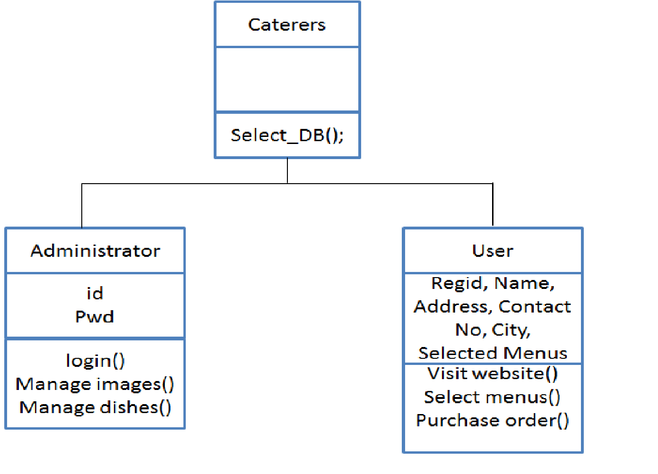

**Use Case Diagram:-**

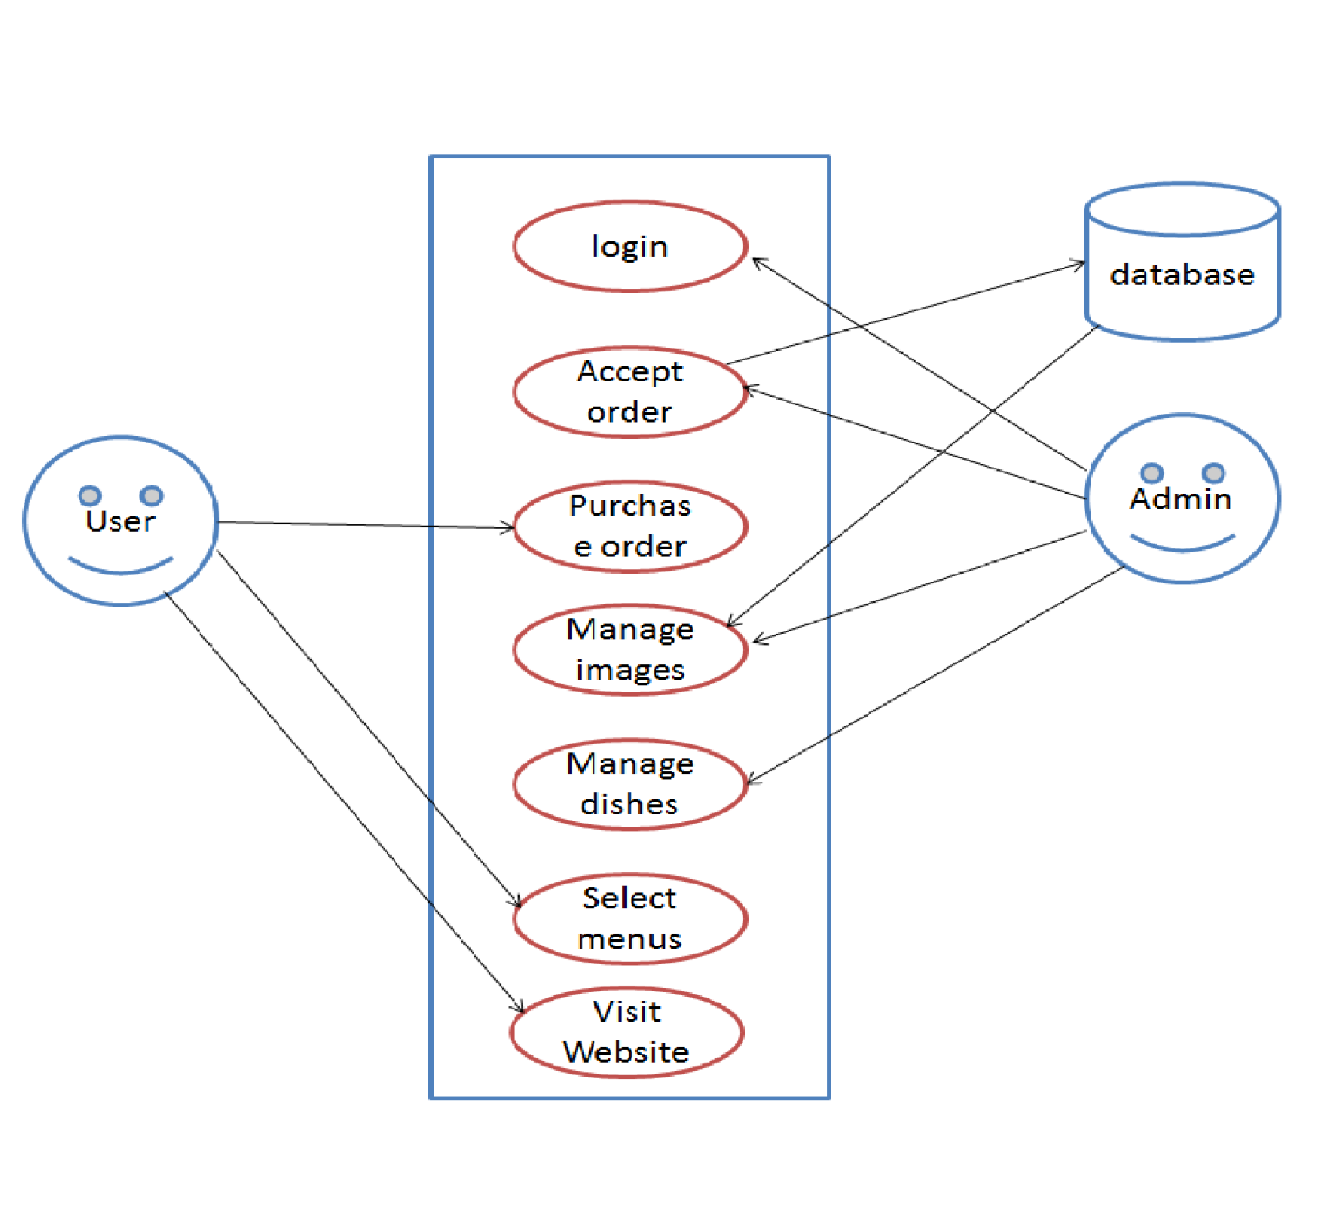

**Activity Diagram:-**

**Admin:-**

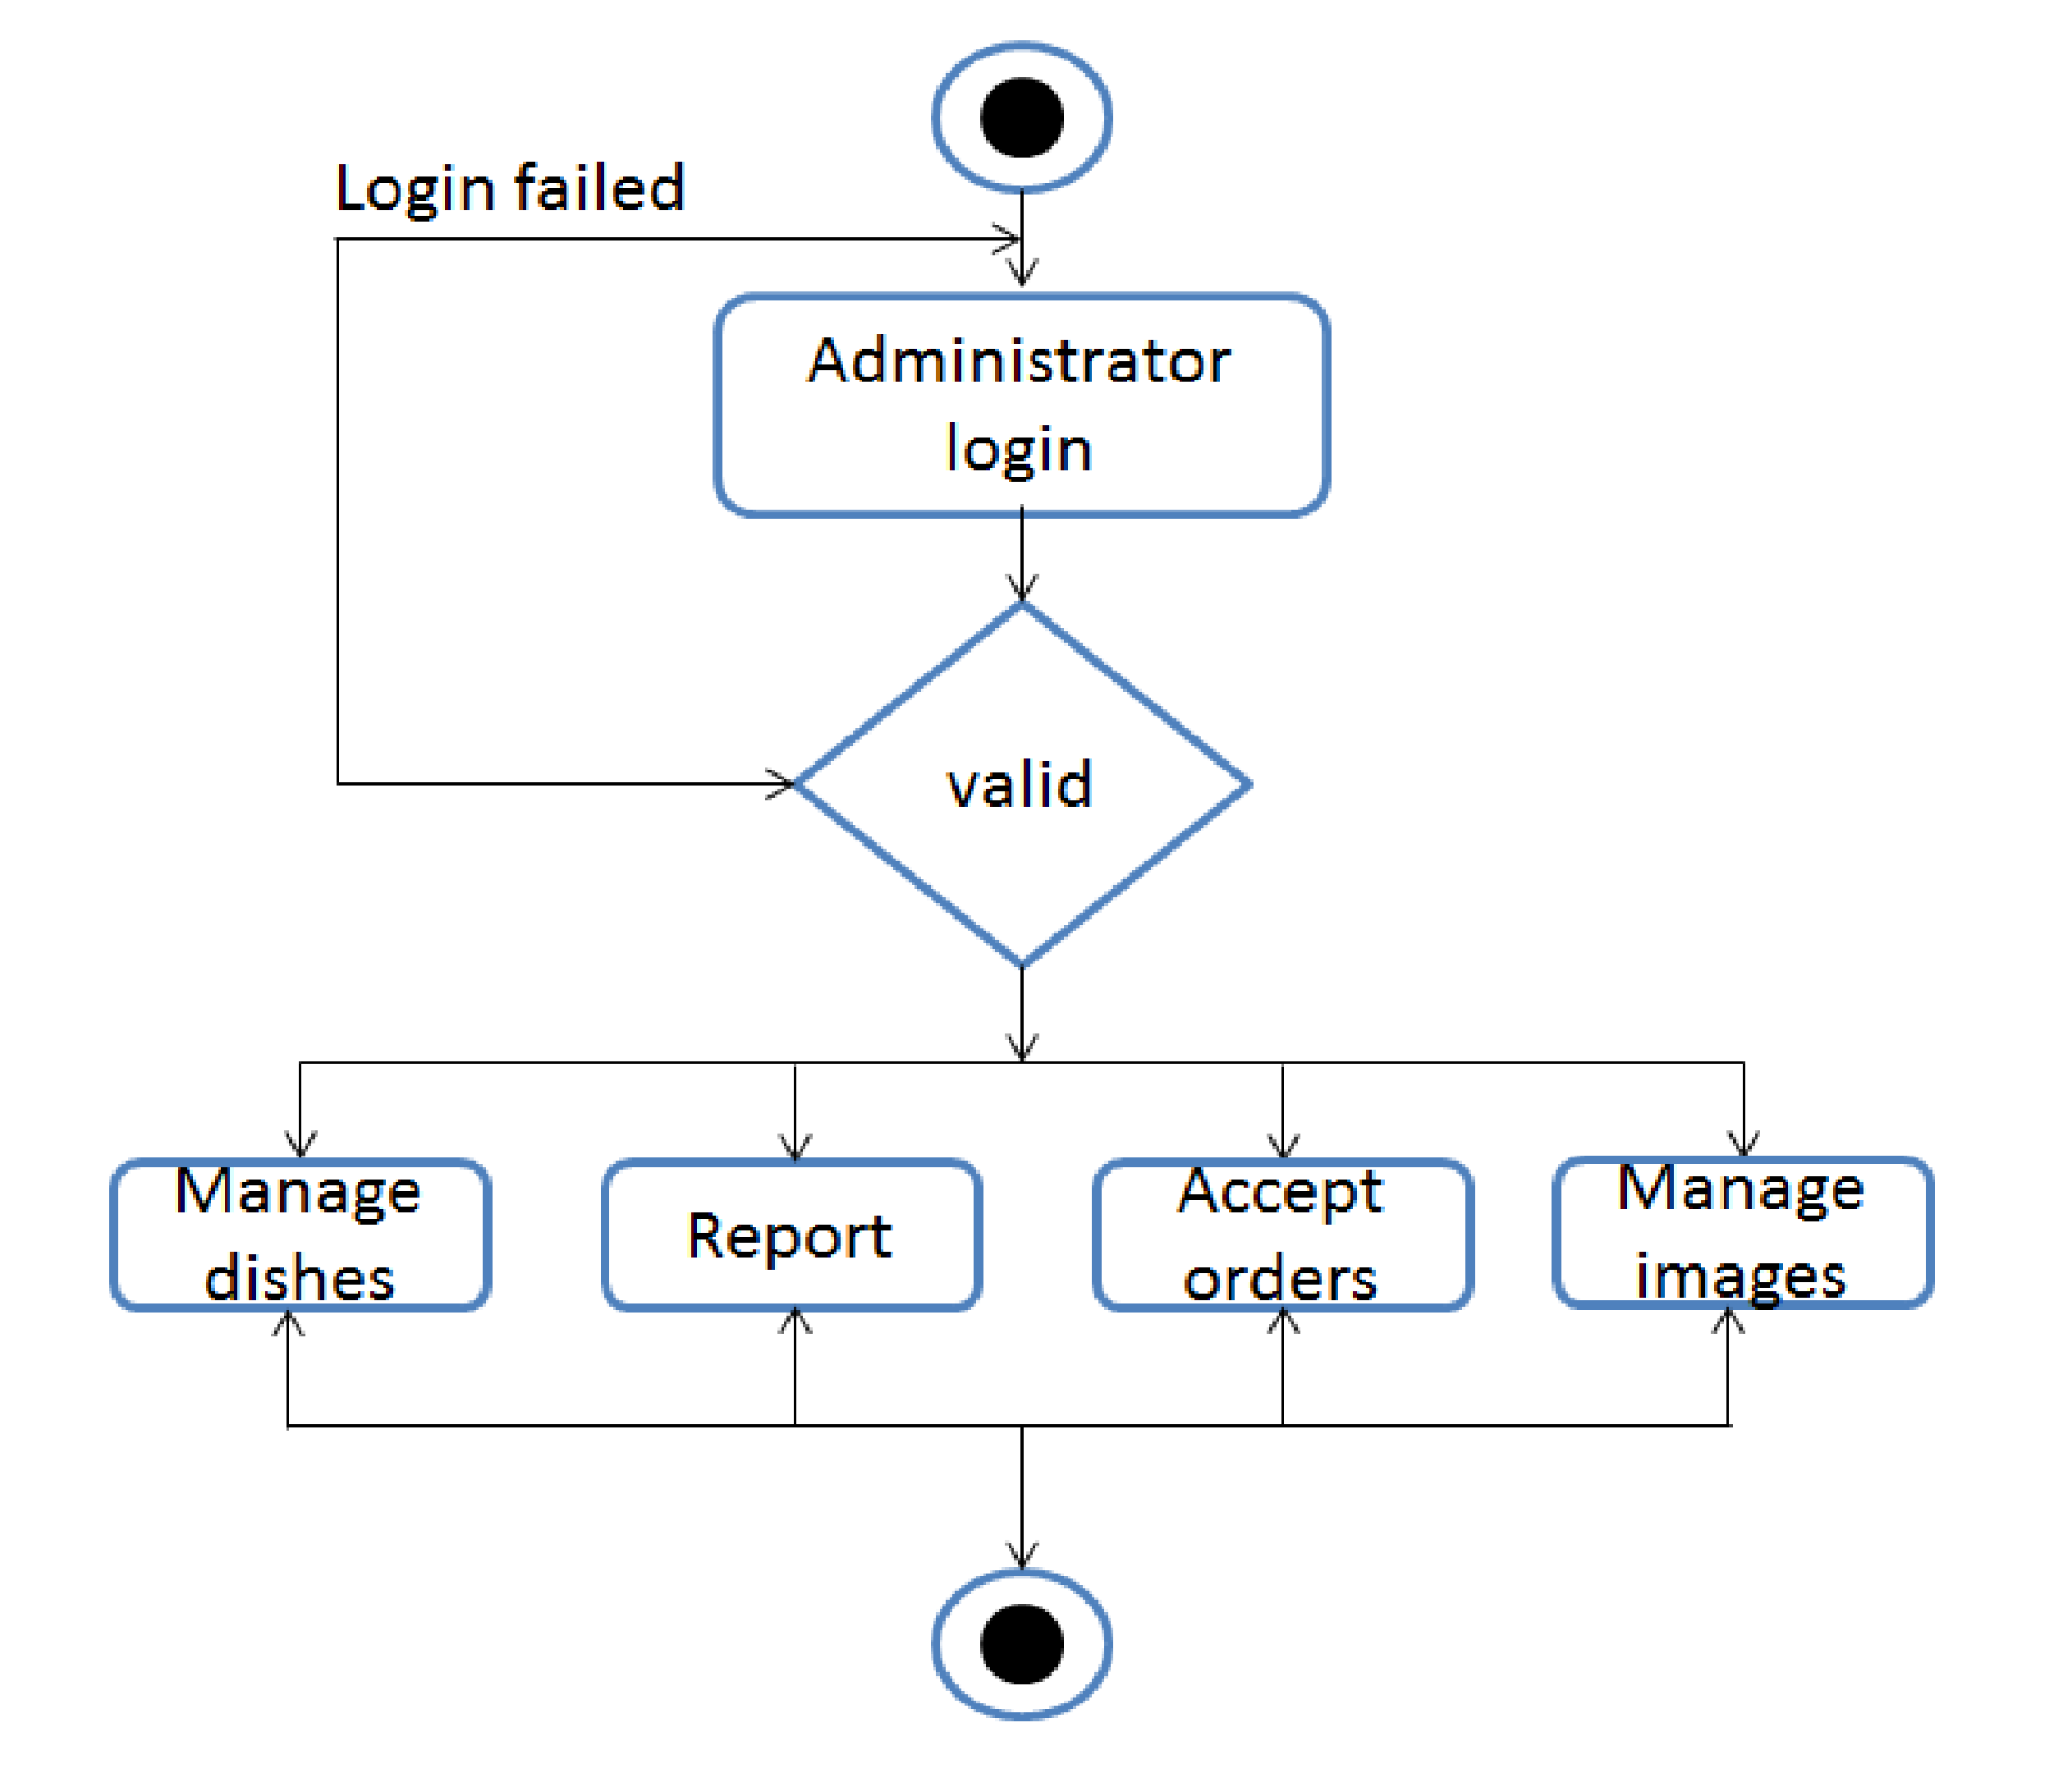

User:-

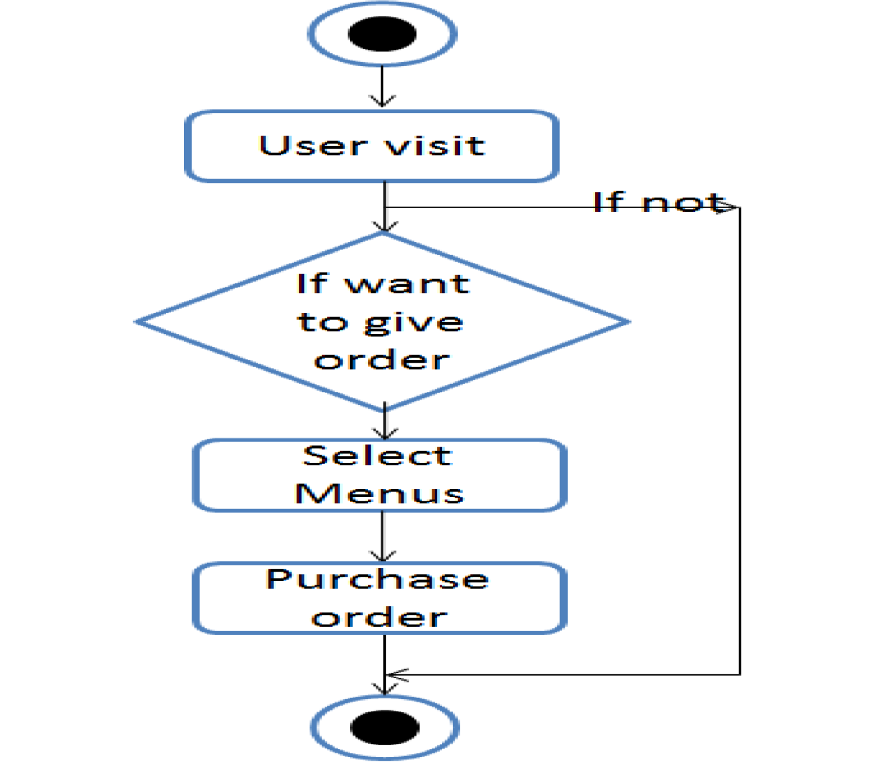

**ERD Diagram:-**

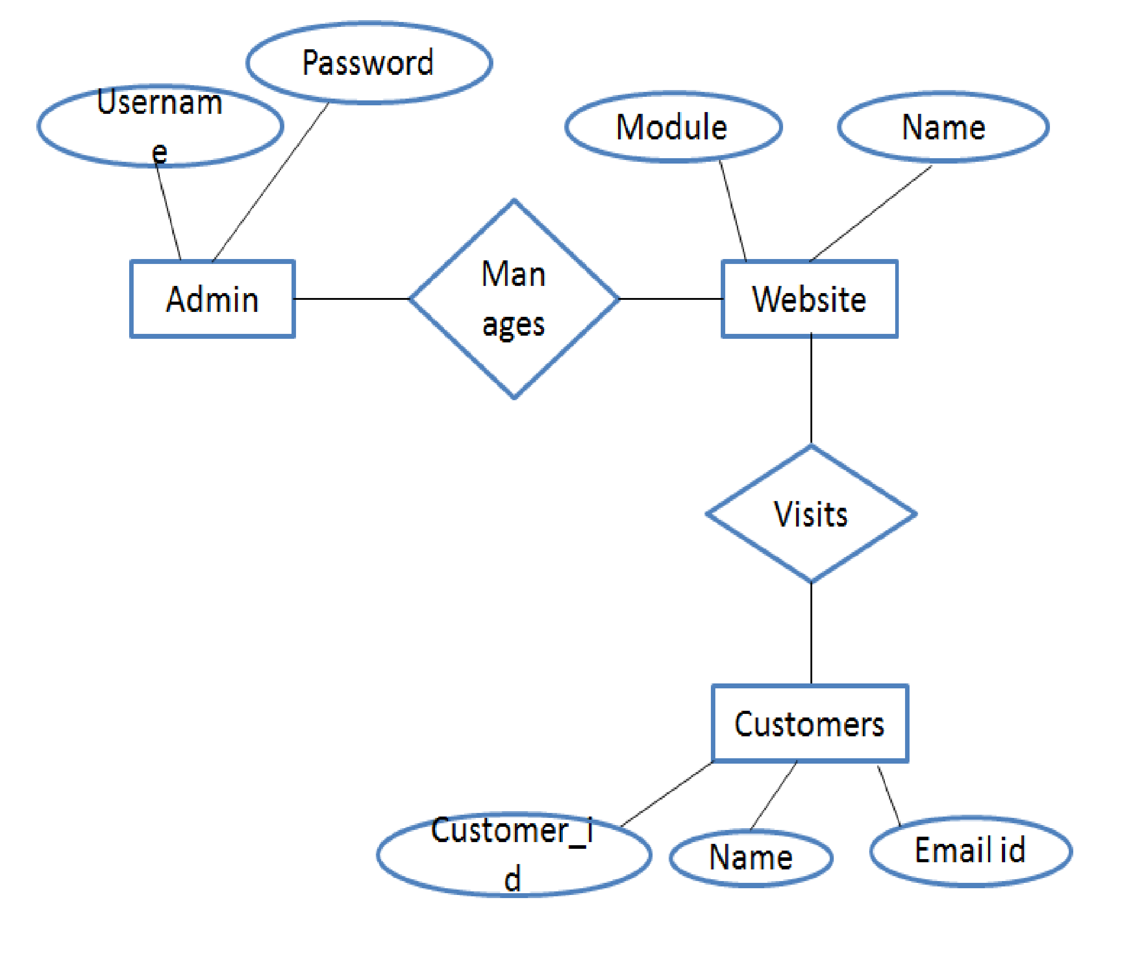

**Collaboration diagram:-**

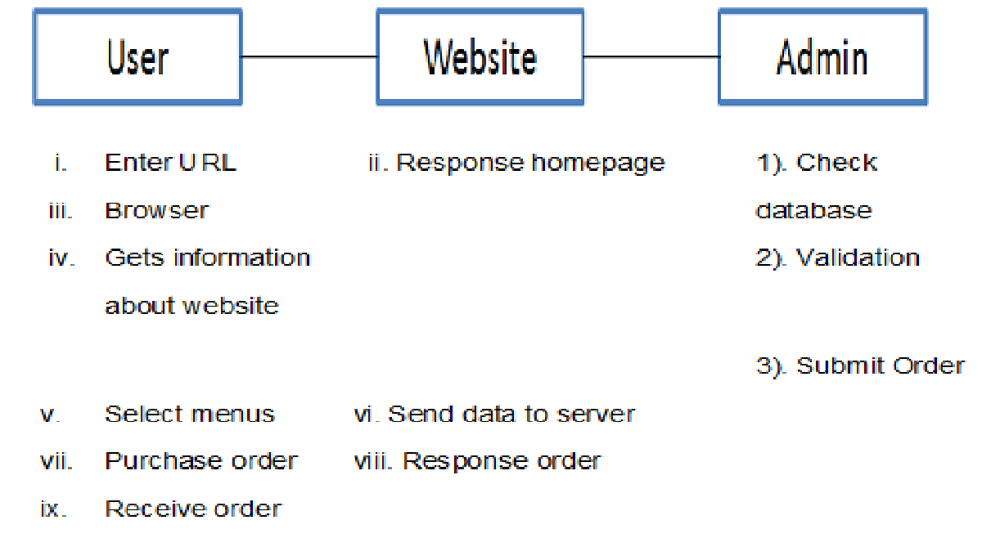

**DATA DICTIONARY**

**User Order Table**

|  |  |  |
| --- | --- | --- |
| Name | Description | Data type |
| id | Order No. | Integer |
| Drink | Drink type | Varchar |
| Vegetable | Vegetable type | Varchar |
| Salad | Salad type | Varchar |
| Sweet | Sweet type | Varchar |
| Roti | Roti type | Varchar |
| Snacks | Snacks type | Varchar |
| Rice | Rice type | Varchar |
| Fname | First name of user | Varchar |
| Mname | Middle name of user | Varchar |
| Lname | Last name of user | Varchar |
| Date | Date of order | Date |
| Mobile no. | Mobile no. if user | Varchar |
| Email | Email id of user | Varchar |
| Venue | Venue of order | Varchar |

**Image Uploading Table:-**

|  |  |  |
| --- | --- | --- |
| Name | Description | Data type |
| id | Image Id | Integer |
| image | Image file | longblob |
| name | Image name | varchar |

**Home:-**

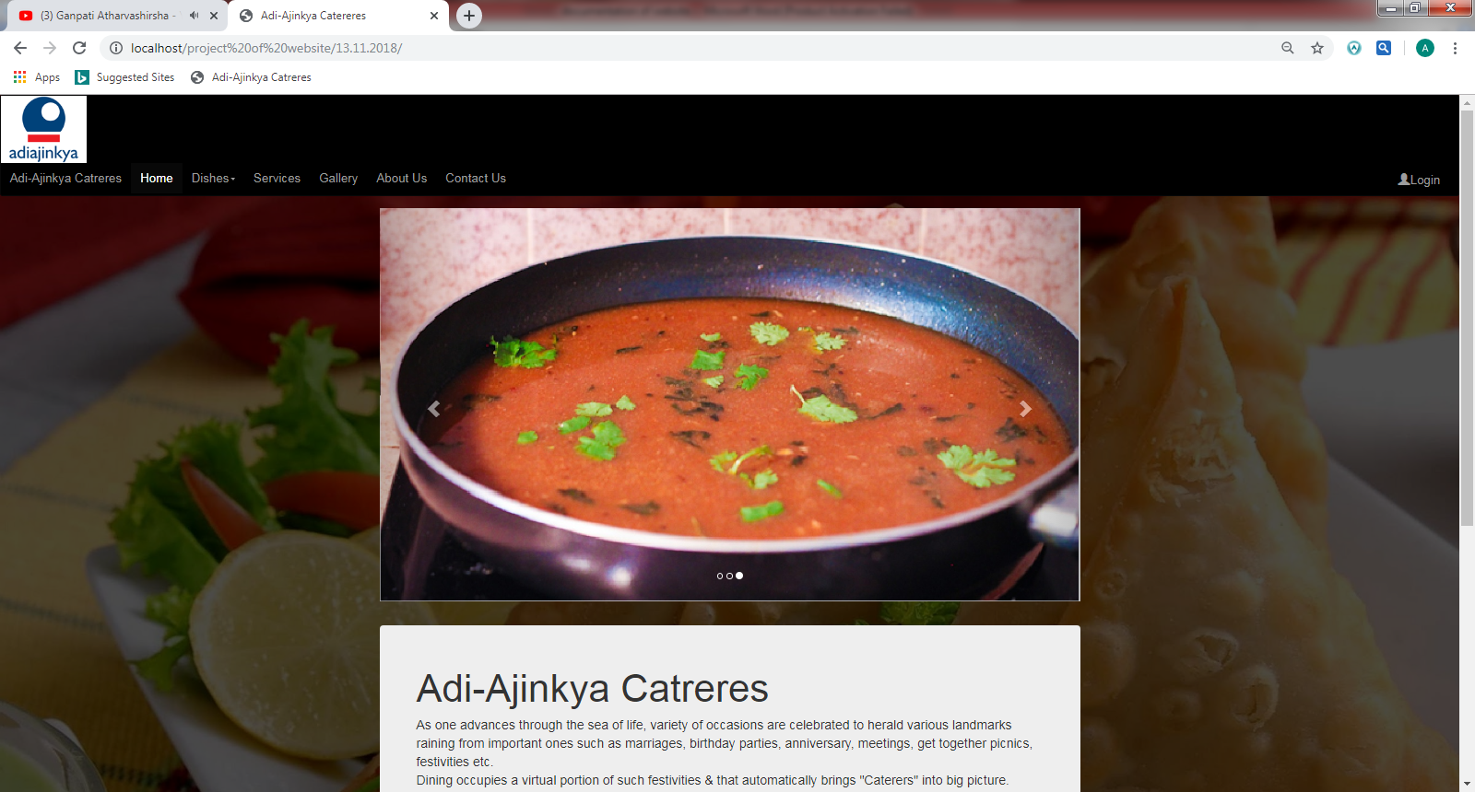

**Dishes:-**

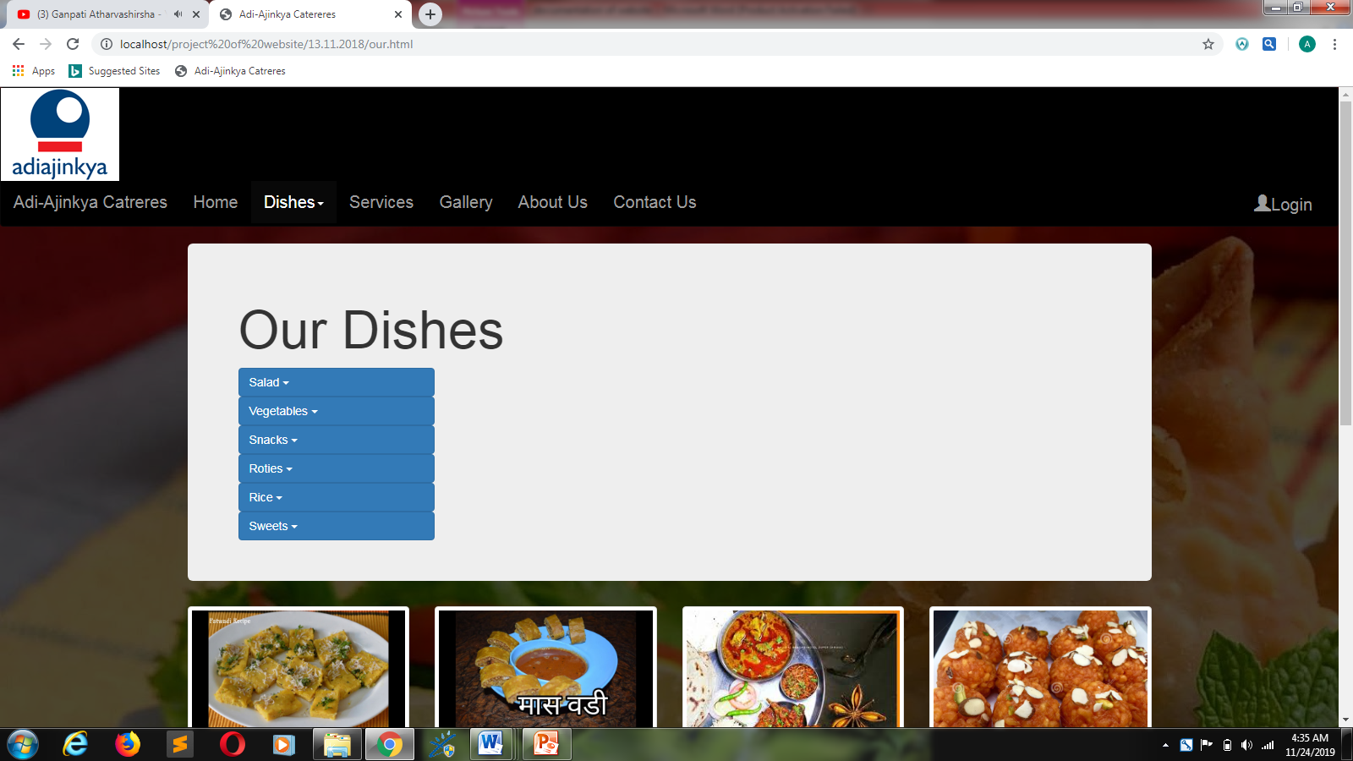

**Order Form:-**

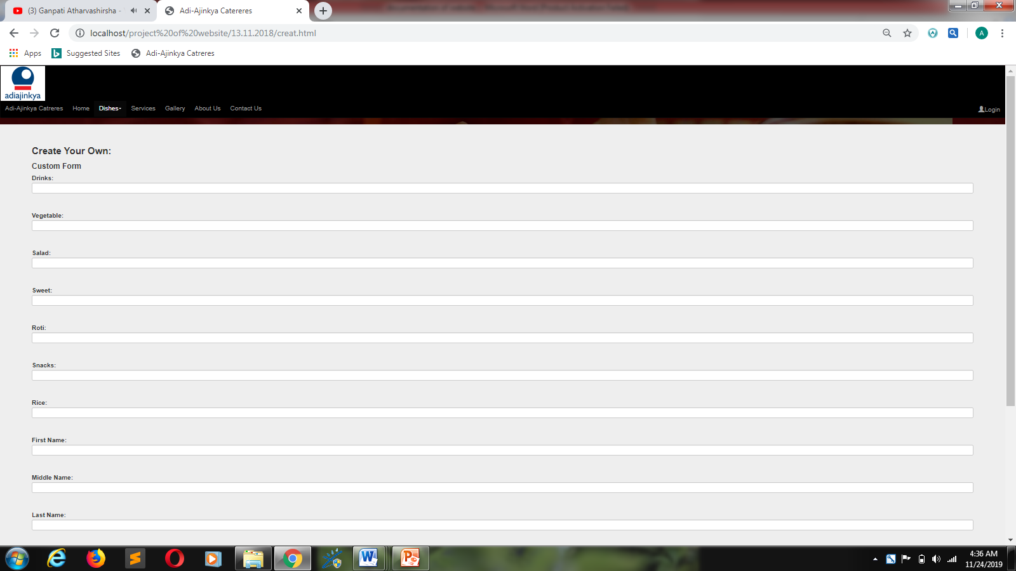

**Service:-**

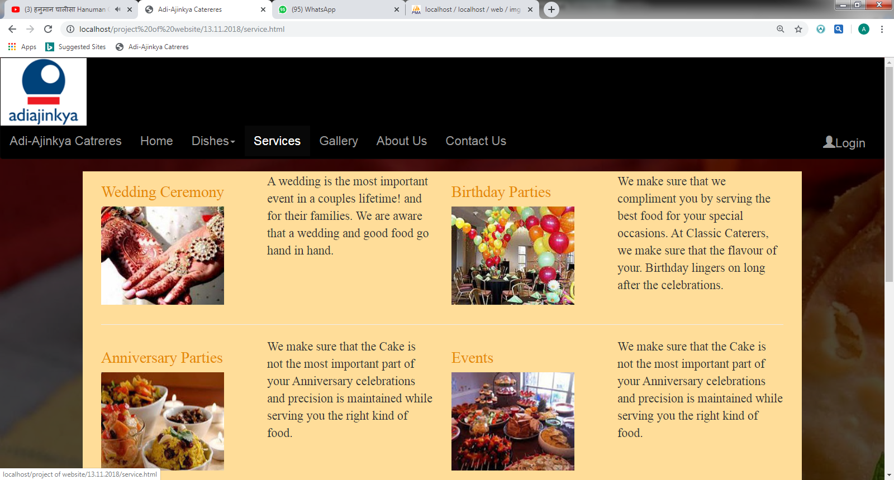

**Gallery:-**

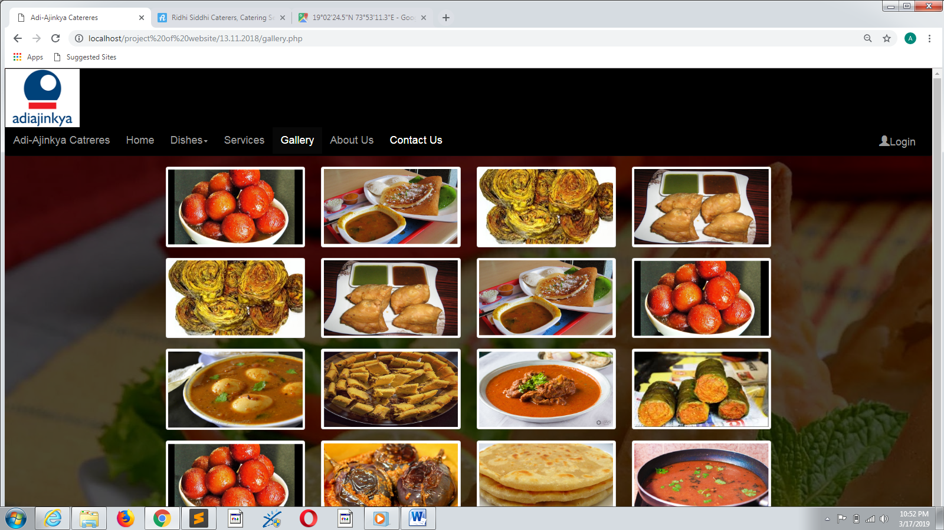

**About Us:-**

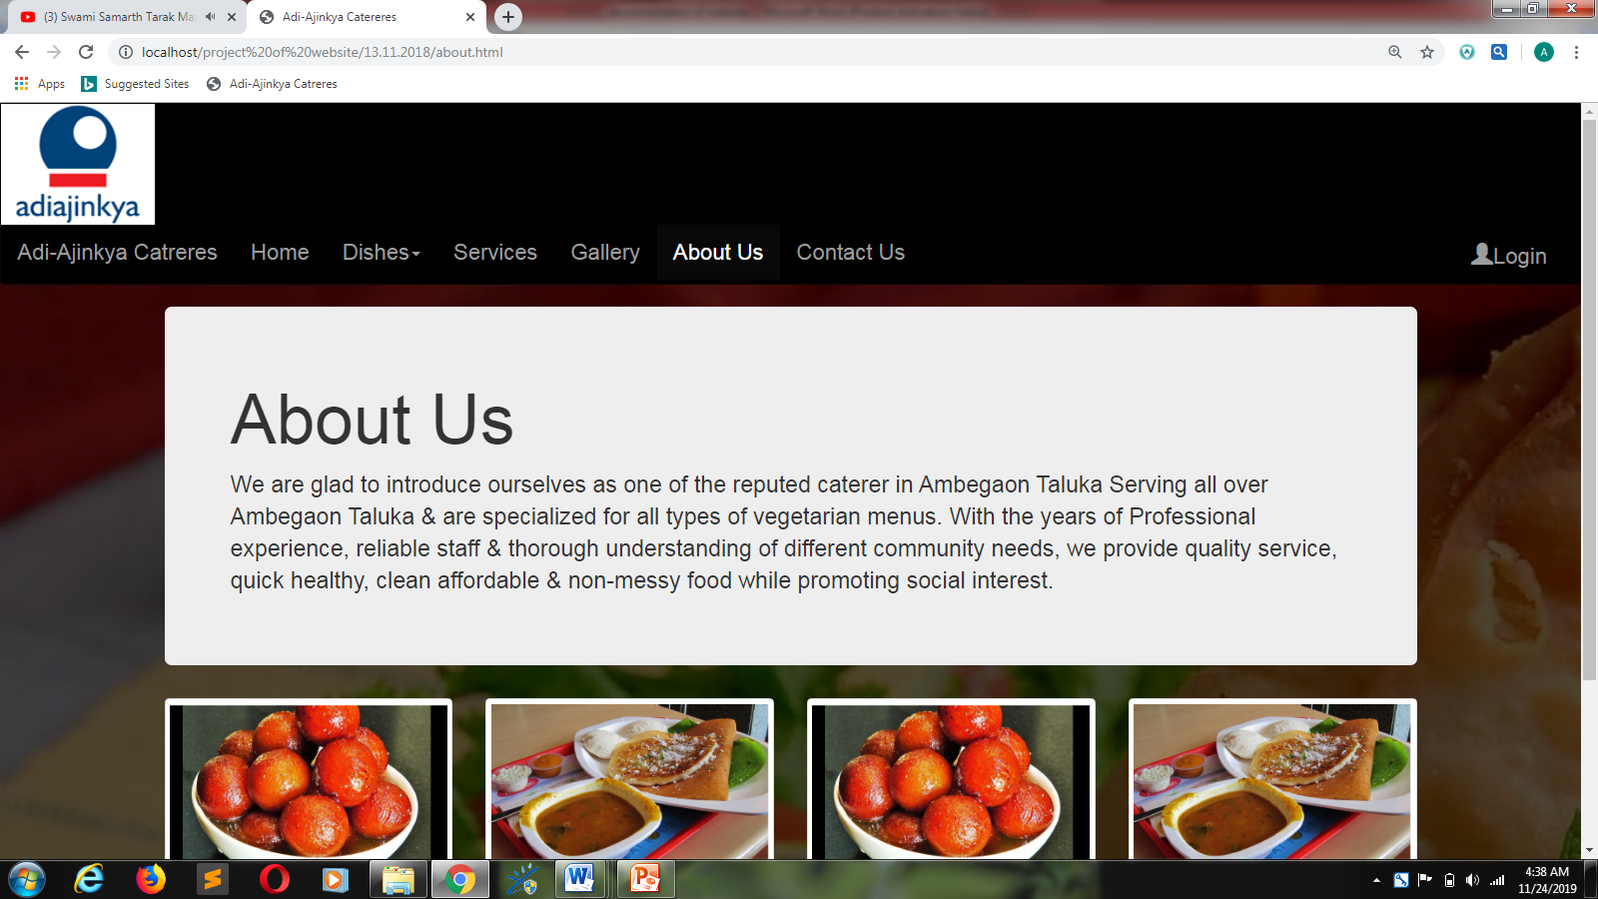

**Contact Us:-**

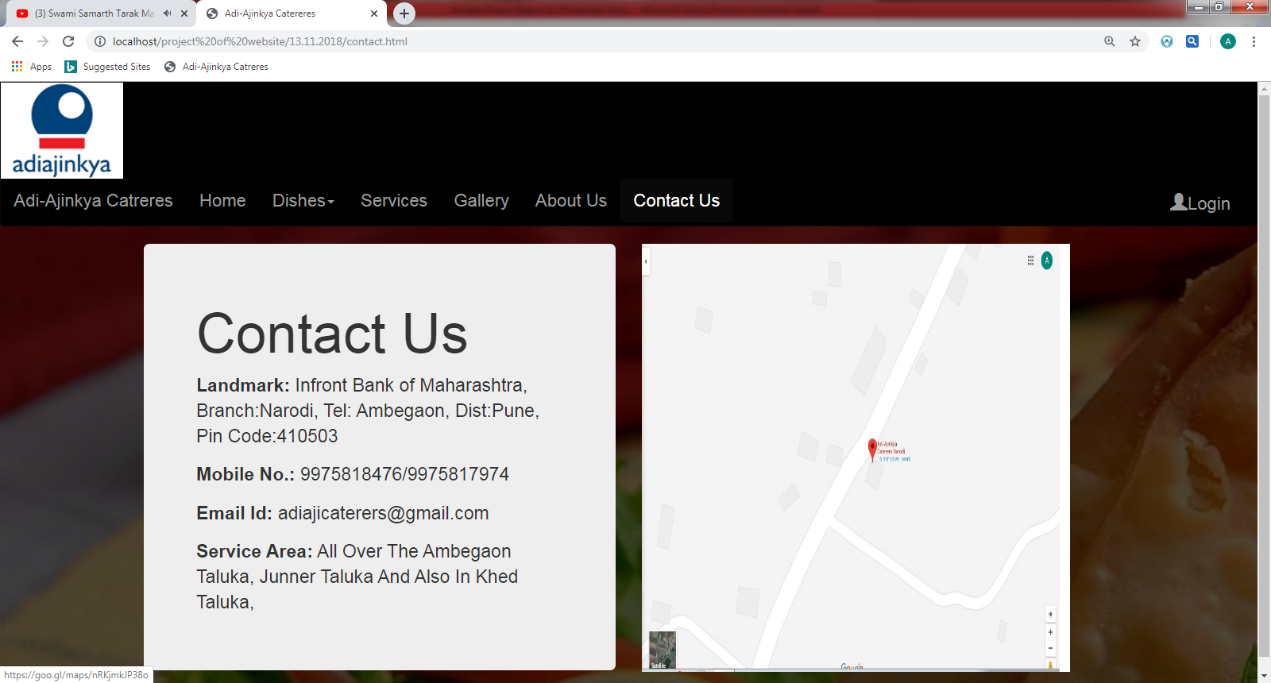

**Admin Login Form:-**

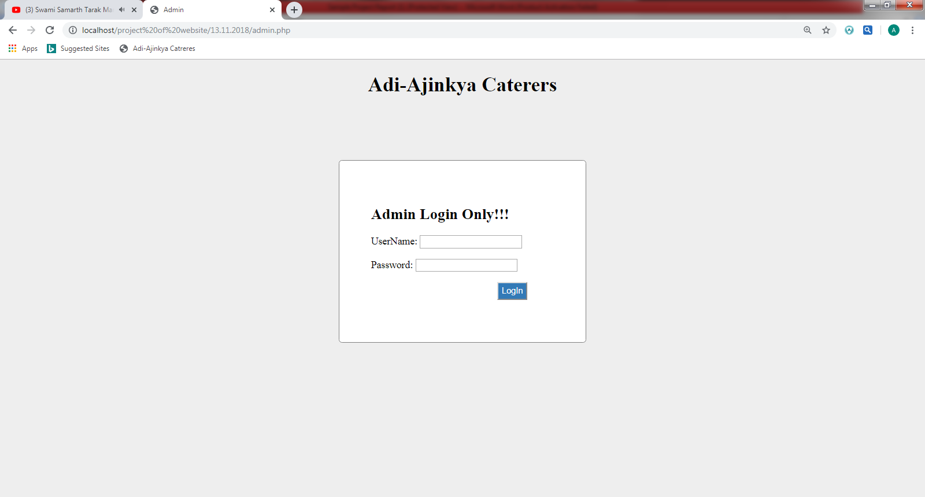

**Admin:-**

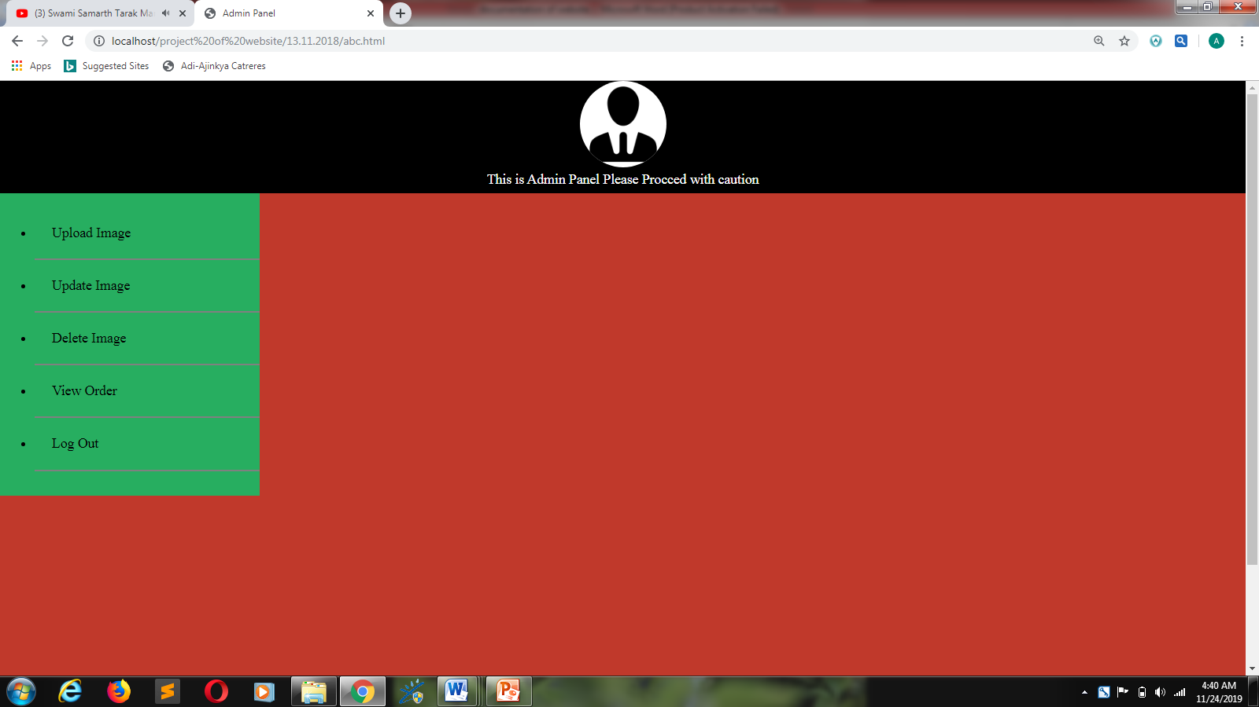

**Limitations and drawbacks:-**

* Admin does not have a notification.
* Cannot pay online.
* The user is not getting the message of the order being confirmed.

**Future Enhancements:-**

* All caterers in the area have to be gathered together to form an institution.
* All should be managed online.

**Conclusion:-**

This website gives you information about caterers, that you understand where to get a meal for your program. It also gets information about how to make new ingredients.

**Bibliography:-**

Books:-

* Advanced Web Technology

(Published by: A B Nimbalkar)

* ONLINE REFERENCE:-
* W3school.com
* Bootstrap v3.3.7

**Sample Code:-**

<!DOCTYPE html>

<html lang="en">

<head>

<title>Adi-Ajinkya Catereres</title>

<meta charset="utf-8">

<meta name="viewport" content="width=device-width, initial-scale=1">

<link rel="stylesheet" href="css/bootstrap.min.css">

<link rel="stylesheet" type="text/css" href="css/style.css">

<script src="https://ajax.googleapis.com/ajax/libs/jquery/3.3.1/jquery.min.js"></script>

<script src="js/bootstrap.min.js"></script>

<style type="text/css">

.adi{

font-size: 20px;

}

.Navbar{

background-color: black;

font-size: 20px;

}

.footer {

color: blue;

text-align: center;

font-size: 20px;

}

.scroll{

margin-left: 100px;

margin-right: 100px;

}

</style>

</head>

<body>

<!--Start Header-->

<header style="background-image:linear-gradient(rgba(0,0,0,0.7),rgba(0,0,0,0.7)), url(img/samosa.jpg);">

<!--Start Navbar-->

<nav class="navbar navbar-inverse Navbar">

<div class="logo">

<img src="img/logo1.png">

</div>

<div class="container-fluid">

<div class="navbar-header">

<button type="button" class="navbar-toggle" data-toggle="collapse" data-target="#myNavbar">

<span class="icon-bar"></span>

<span class="icon-bar"></span>

<span class="icon-bar"></span>

</button>

<a class="navbar-brand adi" href="index.html">Adi-Ajinkya Catreres</a>

</div>

<div class="collapse navbar-collapse" id="myNavbar">

<ul class="nav navbar-nav">

<li class="active"><a href="index.html">Home</a></li>

<li class="dropdown"><a class="dropdown-toggle" data-toggle="dropdown" href="#">Dishes<span class="caret"></span></a>

<ul class="dropdown-menu">

<li><a href="our.html">Our Dishes</a></li>

<li><a href="creat.html">Create Your Order</a></li>

</ul>

</li>

<li><a href="service.html">Services</a></li>

<li><a href="gall.php">Gallery</a></li>

<li><a href="about.html">About Us</a></li>

<li><a href="contact.html">Contact Us</a></li>

</ul>

</ul>

<ul class="nav navbar-nav navbar-right">

<li><a href="admin.php"><span class="glyphicon glyphicon-user"></span>Login</a></li>

</ul>

</div>

</div>

</nav>

<!--End Navbar-->

<div class="container">

<!--Start Slider-->

<div id="myCarousel" class="carousel slide" data-ride="carousel">

<!-- Indicators -->

<ol class="carousel-indicators">

<li data-target="#myCarousel" data-slide-to="0" class="active"></li>

<li data-target="#myCarousel" data-slide-to="1"></li>

<li data-target="#myCarousel" data-slide-to="2"></li>

</ol>

<!-- Wrapper for slides -->

<div class="carousel-inner">

<div class="item active">

<img src="imgs/image6.jpg">

</div>

<div class="item">

<img src="imgs/image4.jpg">

</div>

<div class="item">

<img src="imgs/image5.jpg">

</div>

</div>

<!-- Left and right controls -->

<a class="left carousel-control" href="#myCarousel" data-slide="prev">

<span class="glyphicon glyphicon-chevron-left"></span>

<span class="sr-only">Previous</span>

</a>

<a class="right carousel-control" href="#myCarousel" data-slide="next">

<span class="glyphicon glyphicon-chevron-right"></span>

<span class="sr-only">Next</span>

</a>

</div>

<!--End Slider-->

<br>

<br>

<!--Start Jumbotron-->

<div class="jumbotron">

<h1>Adi-Ajinkya Catreres</h1>

<p>As one advances through the sea of life, variety of occasions are celebrated to herald various landmarks raining from important ones such as marriages, birthday parties, anniversary, meetings, get together picnics, festivities etc.<br>

Dining occupies a virtual portion of such festivities & that automatically brings "Caterers" into big picture.<br>

This is how the "Narodi Village"(Now All Over Ambegaon Taluka) has been through the service "Adi-Ajinkya Caterers" who introduced the concept of Catering & The Buffet System in Ambegaon in 2013.</p>

</div>

<!--End Jumbotron-->

<br>

<!--Start Thumbnail-->

<div class="row">

<div class="col-xs-6 col-md-3 col-sm-4">

<a href="#" class="thumbnail">

<img src="imgs/image1.jpg" alt="...">

</a>

</div>

<div class="col-xs-6 col-md-3 col-sm-4">

<a href="#" class="thumbnail">

<img src="imgs/img2.jpg" alt="...">

</a>

</div>

<div class="col-xs-6 col-md-3 col-sm-4">

<a href="#" class="thumbnail">

<img src="imgs/img3.jpg" alt="...">

</a>

</div>

<div class="col-xs-6 col-md-3 col-sm-4">

<a href="#" class="thumbnail">

<img src="imgs/image4.jpg" alt="...">

</a>

</div>

<div class="col-xs-6 col-md-3 col-sm-4">

<a href="#" class="thumbnail">

<img src="imgs/image3.jpg" alt="...">

</a>

</div>

<div class="col-xs-6 col-md-3 col-sm-4">

<a href="#" class="thumbnail">

<img src="imgs/image5.jpg" alt="...">

</a>

</div>

<div class="col-xs-6 col-md-3 col-sm-4">

<a href="#" class="thumbnail">

<img src="imgs/image6.jpg" alt="...">

</a>

</div>

<div class="col-xs-6 col-md-3 col-sm-4">

<a href="#" class="thumbnail">

<img src="imgs/image7.jpg" alt="...">

</a>

</div>

<div class="col-xs-6 col-md-3 col-sm-4">

<a href="#" class="thumbnail">

<img src="imgs/image8.jpg" alt="...">

</a>

</div>

<div class="col-xs-6 col-md-3 col-sm-4">

<a href="#" class="thumbnail">

<img src="imgs/image9.jpg" alt="...">

</a>

</div>

<div class="col-xs-6 col-md-3 col-sm-4">

<a href="#" class="thumbnail">

<img src="imgs/image10.jpg" alt="...">

</a>

</div>

<div class="col-xs-6 col-md-3 col-sm-4">

<a href="#" class="thumbnail">

<img src="imgs/image11.jpg" alt="...">

</a>

</div>

</div>

<!--End Thumbnail-->

</div>

</header>

<!--End Header-->

</body>

</html>